In my previous article i asked a question “How do we combine precision and recall scores into one?” instead of carrying precision in one pocket and recall in the other one the best idea is to try it in the extreme example.
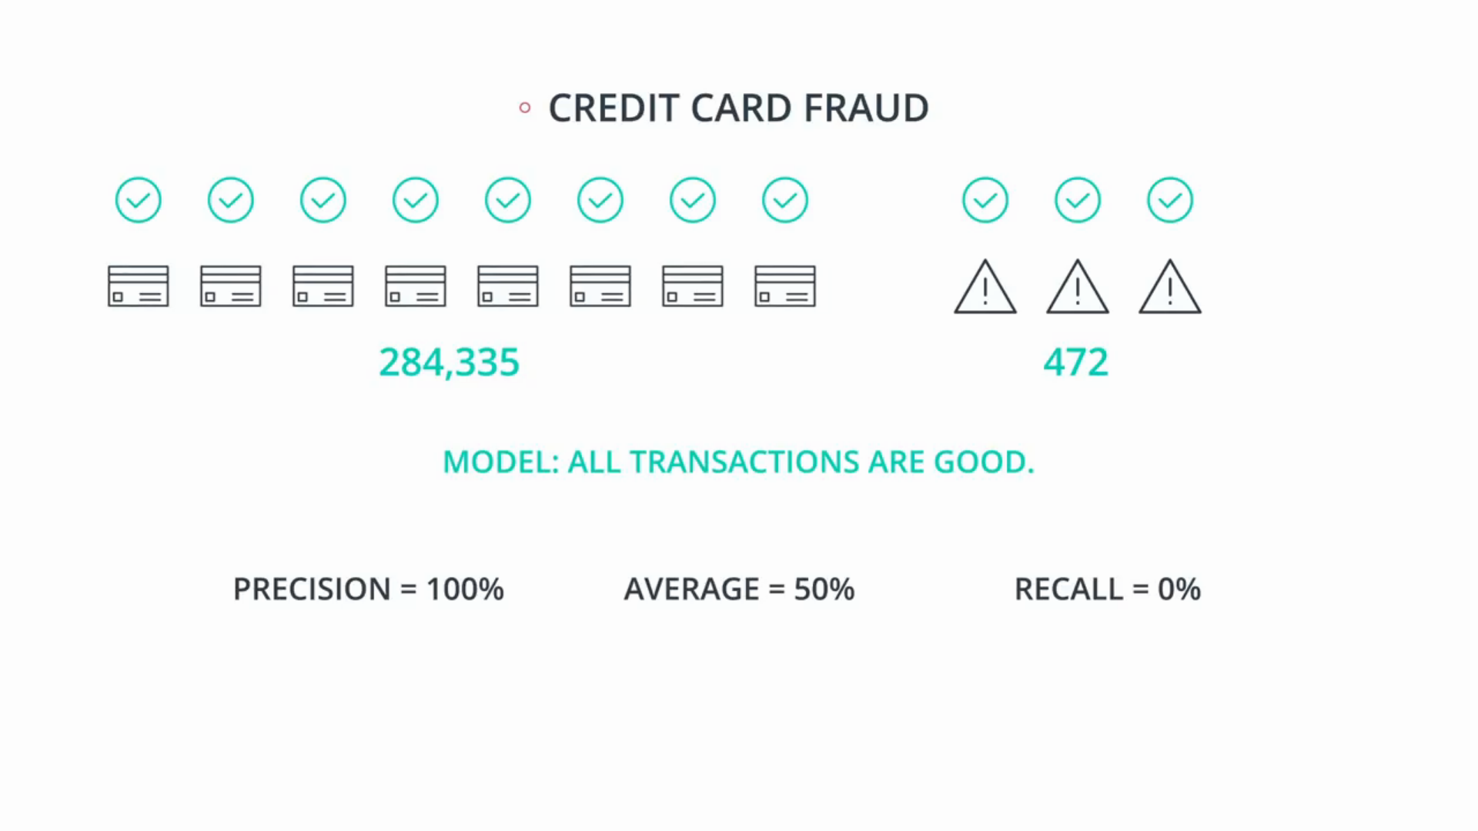
So the credit card fraud example we have a bunch of good and fraudulent credit card transactions. The above we have a terrible model one which says, “All transactions are good.” So what is the precision of this model? 100% since we made zero mistakes among the one who predicted positive, which is what precision tries to measure.
So let’s say this model has 100% precision. Now, as for the recall, the recall is, how many of the fraudulent transactions did we catch?
Well, since we caught none, this number is 0%.
So the average between precision and recall is 50% it’s the average of 100 and zero.

Now the question is, do i want to give this horrendous model of 50%? i think it’s really high score for such a lousy model. I would like to give it much lower score, perhaps even zero. So average is not that good.

Now let’s try the opposite. And let’s try the model that says that all transactions are fraudulent.
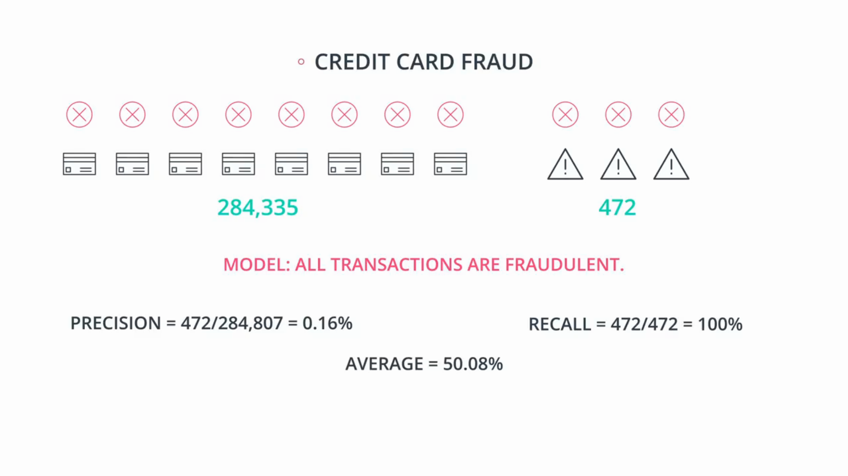
What is the precision of this model? Well out of all the transactions that i said are fraudulent, 472 were actually fraudulent. So the precision is 472 divided by 284,807 which is 0.16% and the recall is actually pretty good, because out of the 472 fraudulent transactions, I caught all of them.
So the recall is 472 divided by 472, which is 100%.
so again, the average of the two is the average of 0.16% and 100% which is 50.08%.

Again, a very high score for a really lousy model.
So we want to give it a lower score or maybe something close to zero. So, in summary, average is not the greatest thing.
In principle if either precision or recall is very low. We want the number to be low even if the other one is high. So here’s a solution.

There’s another type of average called the harmonic mean, and it works as follows.
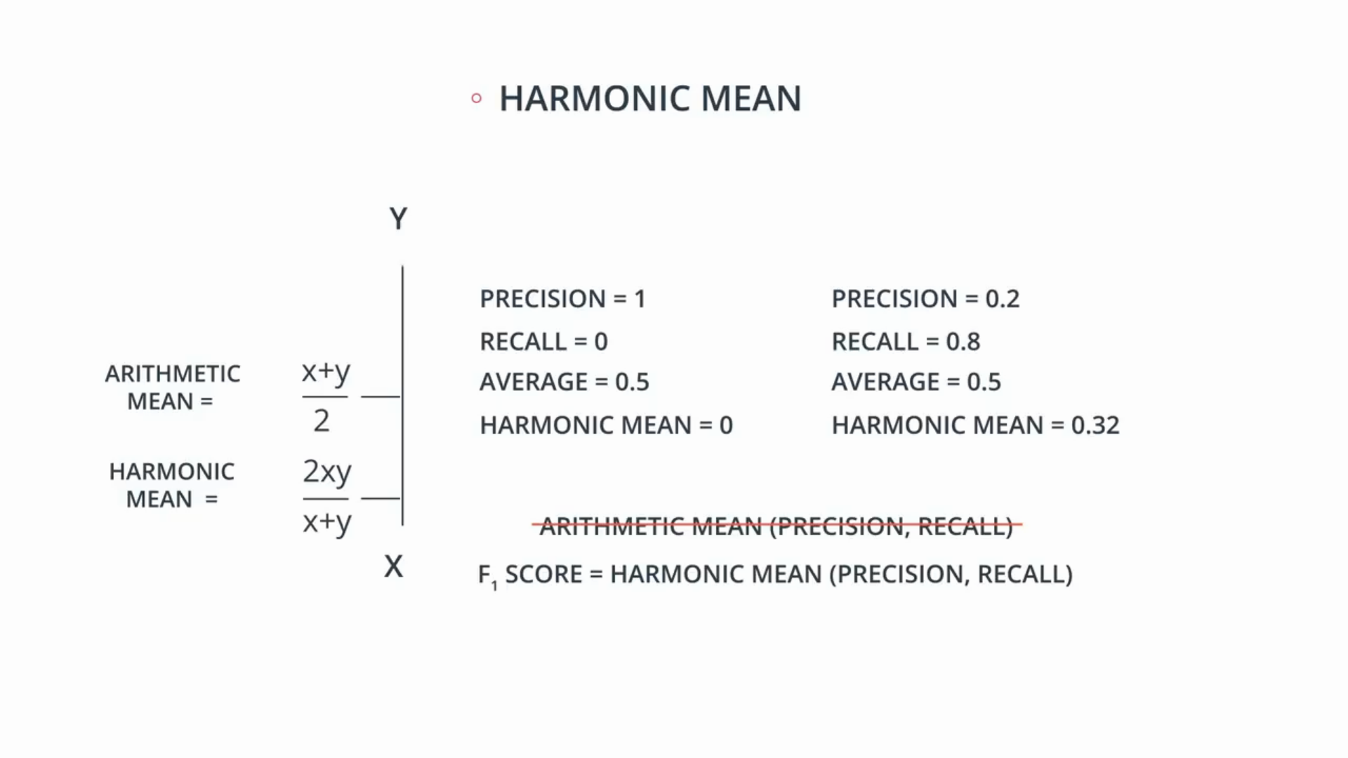
Let’s say we have two numbers, X and Y. X is smaller than Y and we have their arithmetic mean over there! That is the average, X plus Y divided by two. And we have something called the harmonic mean which is defined by 2XY / (X+Y) its kind of an average in the sense that if the two numbers are equal, we get X or Y and it always lies between X and Y.

But actually, it’s a mathematical fact that the harmonic mean is always less than the arithmetic mean. So it’s closer to the smaller number than to the higher number.

So let’s look at the above example. If the precision is 1 and the recall is 0, the average is 0.5, but the harmonic mean is 0.

Let’s look the second example. If the precision is 0.2 and the recall is 0.8, then the arithmetic mean is 0.5, but the harmonic mean is 0.32. So it’s closer to the lower number, so from now on, we will not be using the average or arithmetic mean, we’ll be using the harmonic mean. And that’s going to be called F1 score.

As we said, the F1 score is closer to the smallest, between precision and recall. So if one of them is particularly low, the F1 score kind of raises a flag. The average kind of says, “If one is good, but the other one is bad, then the average is okay.”

But the F1 score raises the flag if one of them is small. So we can now go back to the credit card fraud example and calculate the F1 score.
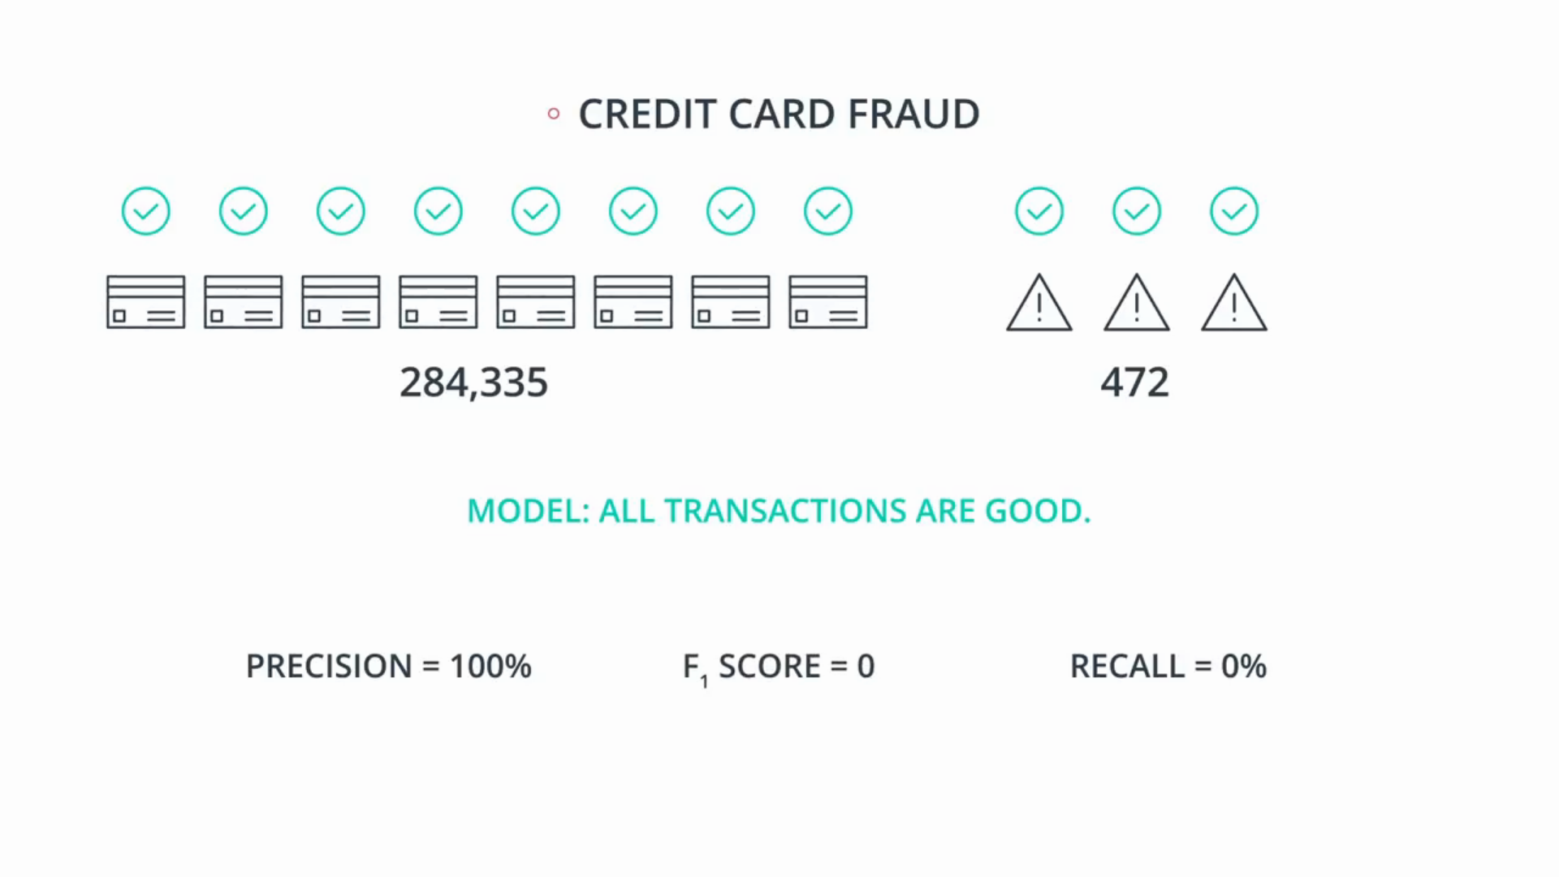
Since is going to be the harmonic mean between the precision, which is 100% and the recall, which is zero, we can plug in the formula and actually get an F1 score of zero. This is much closer to what the models should score.

